English I
Weekly Letter
January 4-6

Wow, I am so proud of you! After grading your essays for the final exams, it is evident that the majority of you have grown leaps and bounds in your writing skills since the beginning of the year. I hope you feel confident and empowered by these skills so you can express and defend your thoughts and opinions more clearly. This is such a life-long skill. With that said, you have now shown mastery of comparison and informative writing. We will continue to visit these forms of writing; however, we are going to add to your writing repertoire by adding argument to the toolbox. As a result, we will begin this new semester focusing on reading Macbeth, writing an argumentative essay, analyzing and writing poetry and acting out the dramatic poem; Romeo & Juliet by William Shakespeare. We have a lot of adventures in store for us. I am so glad you are up for the challenge.
W Weekly Letter
Exam survey—what did you think?
Review the objective & essay sections of the final exam---reflect on changes you have mastered in writing the essay and knowing the writing devices required in an essay. What are some of the things you have mastered?
HMWK: Please write a one page, typed, reflective Letter on what new things you learned 1st semester. In addition, please purchase or bring in Macbeth by Monday, January 9th. I use the Folger’s Edition of the play—see website https://www.amazon.com/Macbeth-Folger-Shakespeare-Library-William/dp/0743477103/ref=sr_1_1?ie=UTF8&qid=1482417148&sr=8-1&keywords=macbeth+folgers
Macbeth (Folger Shakespeare Library) Mass Market Paperback – July 1, 2003 by William Shakespeare (Author), Dr. Barbara A. Mowat (Editor), Paul Werstine Ph.D. (Editor)

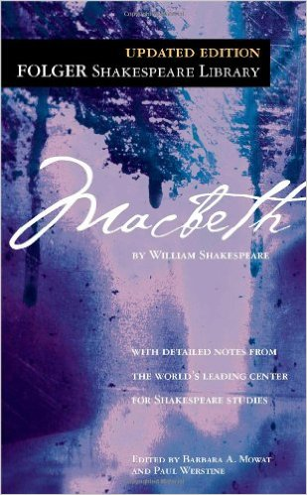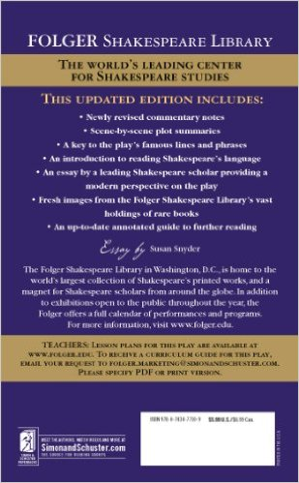

TH Collect reflections & Discuss
PowerPoint on Tragedy and dramatic techniques
HMWK: Research the Globe Theater, Elizabethan Times, and William Shakespeare and write a one page expository response to your findings

F Share info on Elizabethan Times, Shakespeare, Globe Theater—Watch A&E Video
HMWK: Buy Macbeth and bring it to class on Monday


